**Do Premier League Wages or Turnover Predict League Positions? An Investigation**

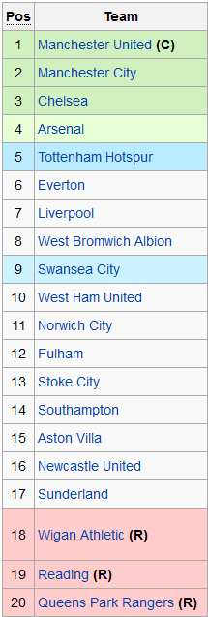The Premier League clubs have just released their data from the 2012-13 season which shows exactly how much each club in the Premier League spent on wages last year, and also their total turnover. This can be easily plotted on a [scatter graph](http://www.alcula.com/calculators/statistics/correlation-coefficient/" \t "_blank) to test how strong the correlation is between spending and league position and also between turnover and league position.

[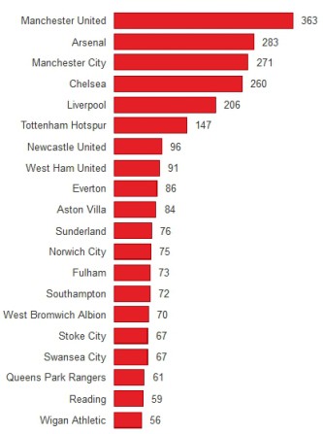](http://1millionmonkeystyping.files.wordpress.com/2014/05/turnover.jpg)[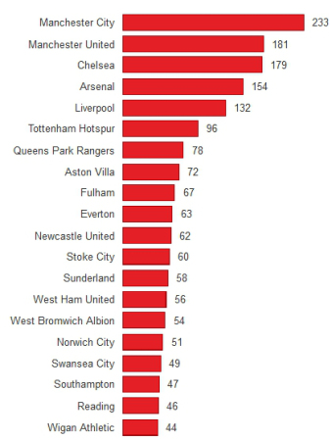](http://1millionmonkeystyping.files.wordpress.com/2014/05/wage-bill.jpg)**WAGES TURNOVER**

|  |  |  |  |  |
| --- | --- | --- | --- | --- |
| **WAGES** | **POSITION** |  | **TURNOVER** | **POSITION** |
|  |  |  |  |  |
|  |  |  |  |  |
|  |  |  |  |  |
|  |  |  |  |  |
|  |  |  |  |  |
|  |  |  |  |  |
|  |  |  |  |  |
|  |  |  |  |  |
|  |  |  |  |  |
|  |  |  |  |  |
|  |  |  |  |  |
|  |  |  |  |  |
|  |  |  |  |  |
|  |  |  |  |  |
|  |  |  |  |  |
|  |  |  |  |  |
|  |  |  |  |  |
|  |  |  |  |  |
|  |  |  |  |  |

**Do Premier League Wages or Turnover Predict League Positions? An Investigation**

The Premier League clubs have just released their data from the 2012-13 season which shows exactly how much each club in the Premier League spent on wages last year, and also their total turnover. This can be easily plotted on a [scatter graph](http://www.alcula.com/calculators/statistics/correlation-coefficient/" \t "_blank) to test how strong the correlation is between spending and league position and also between turnover and league position.

[](http://1millionmonkeystyping.files.wordpress.com/2014/05/turnover.jpg)[](http://1millionmonkeystyping.files.wordpress.com/2014/05/wage-bill.jpg)**WAGES TURNOVER**

|  |  |  |  |  |
| --- | --- | --- | --- | --- |
| **WAGES** | **POSITION** |  | **TURNOVER** | **POSITION** |
|  |  |  |  |  |
|  |  |  |  |  |
|  |  |  |  |  |
|  |  |  |  |  |
|  |  |  |  |  |
|  |  |  |  |  |
|  |  |  |  |  |
|  |  |  |  |  |
|  |  |  |  |  |
|  |  |  |  |  |
|  |  |  |  |  |
|  |  |  |  |  |
|  |  |  |  |  |
|  |  |  |  |  |
|  |  |  |  |  |
|  |  |  |  |  |
|  |  |  |  |  |
|  |  |  |  |  |
|  |  |  |  |  |

**Analysis and Teacher Solutions**

**All this content taken from my site** [**www.ibmathsresources.com**](http://www.ibmathsresources.com) **- loads more ideas for investigations on here!**

[](http://1millionmonkeystyping.files.wordpress.com/2014/05/wage-bill.jpg)

**Is there a correlation between Premier League wages and league position?**

[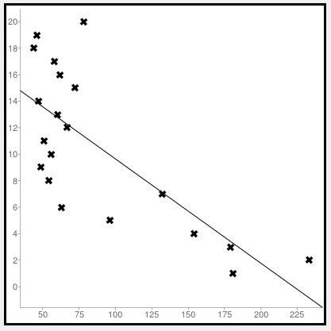](http://1millionmonkeystyping.files.wordpress.com/2014/05/scatter1.jpg)

The mean spending on wages is 89 million pounds.  Our regression line is y = -0.08x + 17.52.  We can see some of the big outliers are QPR (with a big wage bill but low premier league position) and Everton (with a low wage bill relative to others who finished in a similar position).

The Pearson’s product moment correlation coefficient (r) is -0.73.  This is negative because in our case league position is numerically lower the higher up the league you are.  This shows a pretty strong correlation between league spending and league position.  An r value of -1 would be a perfect correlation in our case, whereas 0 would be no correlation.

**Is there a correlation between turnover and league position?**

[](http://1millionmonkeystyping.files.wordpress.com/2014/05/turnover.jpg)

We can also see what the correlation is between league position and overall club turnover (see the bar chart above).  Here we can see there is a huge gulf between the top few clubs and everyone else in the league.  There’s only 40 million pounds difference between the bottom ranked club for revenue Wigan and Newcastle, with the 7th biggest revenue.  But then a massive jump up to those with the top 6 revenues.

[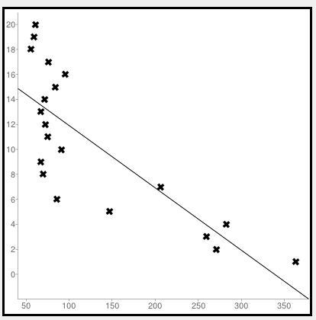](http://1millionmonkeystyping.files.wordpress.com/2014/05/scatter2.jpg)

This time we have a mean turnover of 128 million pounds and a regression line of y = -0.05x + 16.89.   The Pearson’s r value this time is r = -0.79, so there is a slightly stronger correlation than from wages – and this is a strong correlation overall.  So, both wage bills and turnover provide a pretty good predictor of where a team will finish – and also a decent yardstick to measure how well a team has done relative to their resources.

The Championship is famously very competitive – so it will be interesting to see if the same wages and league position correlation that we see in the Premier League also holds here.

**Wage Bill 2012-13 Season (millions of pounds)**

[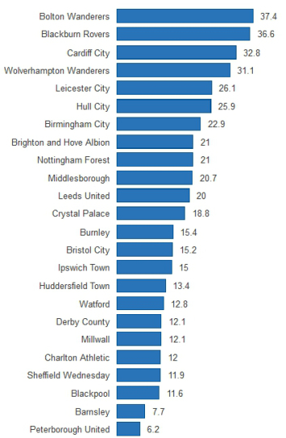](http://1millionmonkeystyping.files.wordpress.com/2014/05/football2.jpg)

Using an online [scatter plot program](http://www.alcula.com/calculators/statistics/linear-regression/" \t "_blank) we can get the following graph:

[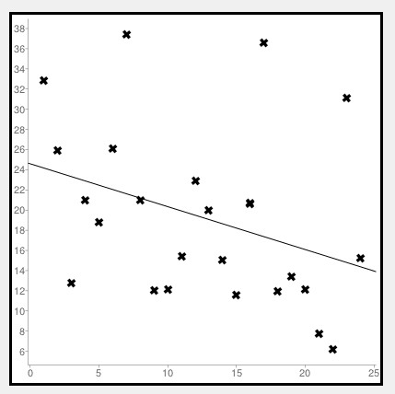](http://1millionmonkeystyping.files.wordpress.com/2014/05/football4.jpg)

Here the league position is on the x axis and the wage bill is on the y axis. In this case if there was a correlation between wages paid and league position we would expect the slope to be negative (as greater wages would lead to a lower league position).  From the graph we can see a pretty weak correlation:

Correlation coefficient (r): -0.3451690473979

Regression line equation: y=24.59-0.43x

The correlation coefficient shows that there is a weak negative correlation.

If we compare this to the scatter graph for the Premier League for the same period (this time the wages are plotted on the y axis – though this will not affect the calculations!)

[](http://1millionmonkeystyping.files.wordpress.com/2014/05/scatter1.jpg)

We can see a stark difference.  This time the correlation coefficient is -0.73, which shows a pretty strong negative correlation.  So what does this show?  Well, it confirms what many people already think about the 2 leagues – the Premier League is overall quite predictable – just by looking at the relative wage bills you can get a pretty good idea about league positions.  The Championship on the other hand is really pretty unpredictable – wages seem to have only a weak correlation with league position.  Indeed Wolves had one of the highest wage bills and yet finished 2nd from bottom.

**Championship Debt Timebomb**

[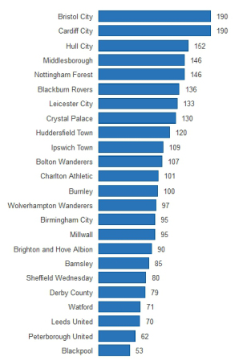](http://1millionmonkeystyping.files.wordpress.com/2014/05/football3.jpg)

This remarkable graphic shows the terrible state of the finances for most Championship clubs.  It shows wages as a percentage of turnover.  Spending 50% of turnover on wages is generally considered a sustainable model for football clubs – yet every club in the table is above this – and the vast majority are spending 95% or more of their turnover just on wages.  Bristol City (who were relegated) were spending a staggering 190% of turnover on wages – i.e nearly twice their total turnover!

This is again quite a contrast to the Premier League, where clubs seem much better run:

[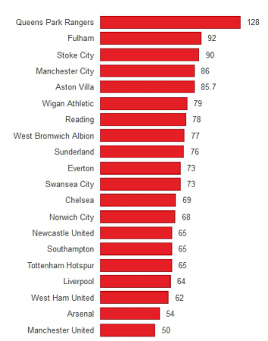](http://1millionmonkeystyping.files.wordpress.com/2014/05/football6.jpg)

Whilst most clubs are spending more than 50% of their turnover, there are only 3 clubs spending more than 90% – and only QPR (who were relegated) spending more than their turnover.

So, the Championship is a much more unpredictable league – but also a financial basketcase.